**Data Analytics and Tableau**

**Name: Nandini Raju Bhalekar**

**Div: T.Y.BSc (DS-BDA)**

**PRN: 1132220450**

**Topic: Netflix Recommendation Algorithm: A Case Study**

* **Introduction:**

In today's world, streaming platforms like Netflix have become a big part of our entertainment. Netflix stands out as a leader in this industry, largely because of its smart recommendation algorithm. This case study explores how Netflix uses data analytics to improve user experience by suggesting shows and movies that viewers are likely to enjoy. The main goal of this recommendation system is to keep users engaged and happy, helping Netflix keep its subscribers and increase its revenue. By understanding how this algorithm works, we can learn more about the connection between data science, viewer behaviour, and business strategies in the entertainment sector.

**Background:**Netflix has a vast library of content, featuring thousands of movies and TV shows in many genres. This abundance of choices can sometimes overwhelm users, making it tough for them to discover new content they might like. Before Netflix introduced its recommendation system, many users found it hard to find suitable shows and movies, which led to frustration and even caused some to cancel their subscriptions.

To visualize how Netflix's algorithm helps address this problem, we will use Tableau, a powerful data visualization tool.

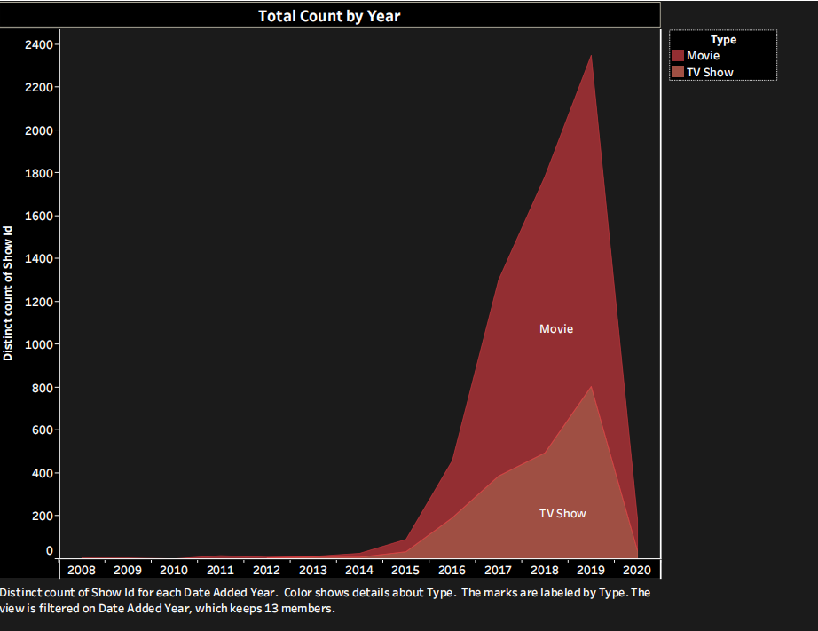

**Chart:** *Distinct Show Count by Year* – This **line chart** shows how Netflix's content library has expanded from 2008 to 2023. It highlights the rapid growth of Netflix's offerings, demonstrating the need for an efficient recommendation system to help users navigate through such a vast selection.

**Problem Definition:**

The key challenge for Netflix was to make sure users could easily find content that matched their tastes and preferences. Without effective recommendations, users might feel lost in a sea of choices and might even decide to leave the platform. The recommendation system plays a vital role in this by using data from users’ past viewing habits to suggest shows and movies that are likely to interest them.

This personalization is crucial, especially since Netflix serves a global audience with diverse interests and cultural backgrounds. The algorithm analyzes various data points, including viewing history, ratings, and user interactions, to create a customized experience for each viewer.

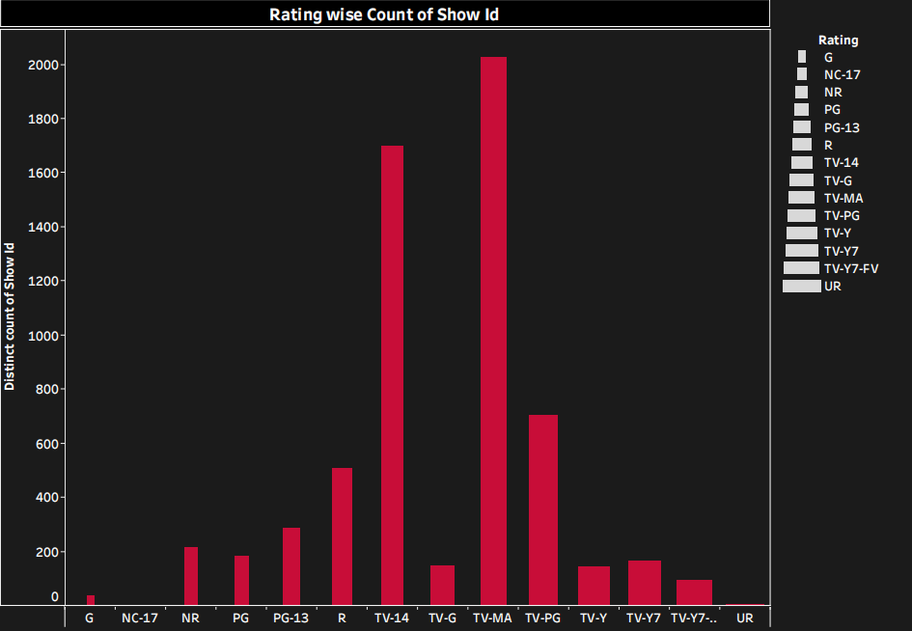

**Chart**: *Rating-wise Show Count – This* ***bar chart*** *categorizes content by ratings such as PG, TV-MA, and R. It provides insights into which types of content are most popular among different age groups and demographics.*

**Objective:**

The primary objective of Netflix's recommendation system is to provide personalized content suggestions tailored to individual users. By doing this, Netflix aims to enhance user engagement, help users discover content faster, and ultimately boost its revenue.

The success of the recommendation algorithm can be evaluated using several metrics, such as Average Revenue Per User (ARPU), membership growth in various regions, and overall user engagement levels.

This goal aligns with Netflix's broader business strategy, which focuses on improving user satisfaction and building long-term loyalty. By ensuring a smooth and enjoyable viewing experience, Netflix can not only retain existing subscribers but also attract new ones through positive reviews and targeted marketing.

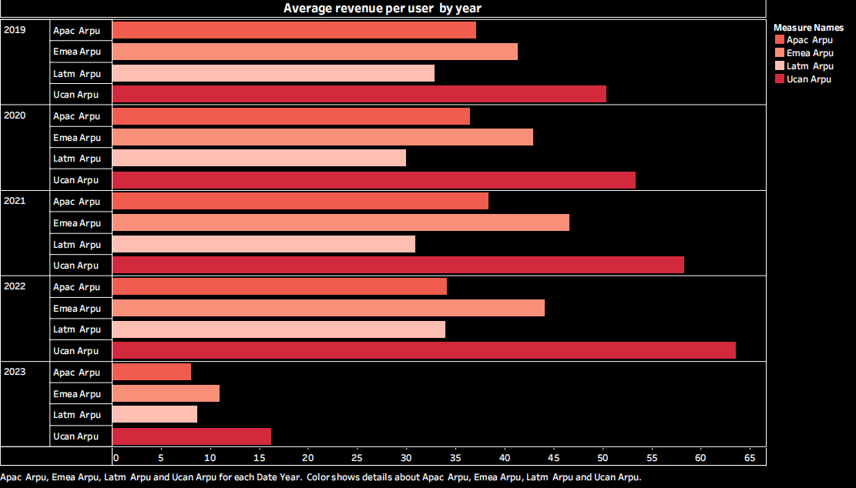

**Chart**: *Revenue by Region and ARPU – A* ***stacked bar chart*** *comparing revenue and ARPU across regions like APAC, EMEA, LATM, and UCAN. This chart illustrates how effective the recommendation system is in different markets and demographics.*

**Methodology:**  
This case study uses Tableau to analyze and visualize important trends in Netflix's data. The focus will be on the following areas:

* **Distinct Show Count by Year**: This analysis showcases how Netflix's content library has grown over time. It emphasizes the need for a recommendation system to help users find what they want in an ever-expanding library.
* **Show Count by Rating**: This metric explores the popularity of content across different rating categories, helping Netflix understand user preferences and fine-tune its recommendations.
* **Membership Growth by Region**: By looking at user growth in regions like APAC, EMEA, LATM, and UCAN, we can see where Netflix's recommendations are most effective and identify areas for improvement.
* **Revenue and ARPU by Region**: This analysis examines how well the recommendation system drives revenue in different regions, providing insight into its financial impact.

**Findings:**The Tableau analysis reveals several important insights:

* **Content Growth**: As Netflix's library expands, a robust recommendation system is essential for helping users discover content they enjoy. With so much available, users may miss out on shows and movies that match their tastes, highlighting the critical role of personalized recommendations.
* **Regional Engagement**: The APAC and EMEA regions show strong membership growth, suggesting that Netflix's recommendation algorithm works well in these markets. On the other hand, the UCAN region has the highest revenue, driven by a greater Average Revenue Per User (ARPU). This indicates that users in this area are more likely to engage with premium content.
* **User Preferences by Rating**: The breakdown of shows by rating reveals different content preferences across various age groups and demographics. By analyzing these preferences, Netflix can further customize its recommendations, enhancing user engagement and satisfaction.

**Explanation of Why You Chose the Case Study**:

The Netflix recommendation algorithm serves as an excellent example of how data science and machine learning can transform user experiences. By studying this topic, we can gain valuable insights into how algorithms operate in a major industry, the mechanisms that keep users engaged, and the impact of personalized suggestions on viewing habits. This case study not only sheds light on the technical aspects of the recommendation system but also illustrates its significance in shaping modern entertainment. The insights gained can inform future developments in similar data-driven applications across various fields.

**Solutions and Implications:**

Netflix’s recommendation algorithm significantly boosts user satisfaction by quickly helping users find content they enjoy. By analyzing viewing habits, the algorithm suggests shows and movies that align with users' preferences, minimizing the time spent searching for something to watch. Increased engagement leads to higher retention rates and ultimately boosts Netflix's revenue.

The success of this recommendation system demonstrates the power of data-driven approaches in enhancing user experiences. By understanding viewer preferences, Netflix can guide content creators in producing shows and movies that resonate with audiences. Moreover, Netflix continuously refines its recommendations by analyzing user feedback and engagement metrics, ensuring the algorithm adapts to changing viewing habits.

This strategy not only benefits Netflix but also serves as a model for other industries aiming to enhance user experiences through personalization. The data analytics principles applied here can be adapted to various fields, helping businesses engage their customers more effectively and build lasting relationships.

**Conclusion:**

Netflix’s recommendation system is vital for its ongoing success, keeping users engaged and driving revenue growth. Using Tableau to visualize important metrics like content growth, user engagement, and regional revenue, this case study highlights how data science is integral to Netflix's achievements. As the platform continues to grow, the recommendation system will remain essential for improving user experience and maintaining its competitive edge in the streaming industry.

In conclusion, the recommendation algorithm not only keeps users satisfied but also plays a crucial role in Netflix's business strategy. By continually refining its approach based on user data, Netflix can ensure that it meets the ever-evolving demands of its audience. The lessons learned from this case study can provide valuable insights for other companies looking to implement similar data-driven strategies, showcasing the power of analytics in today's digital landscape.

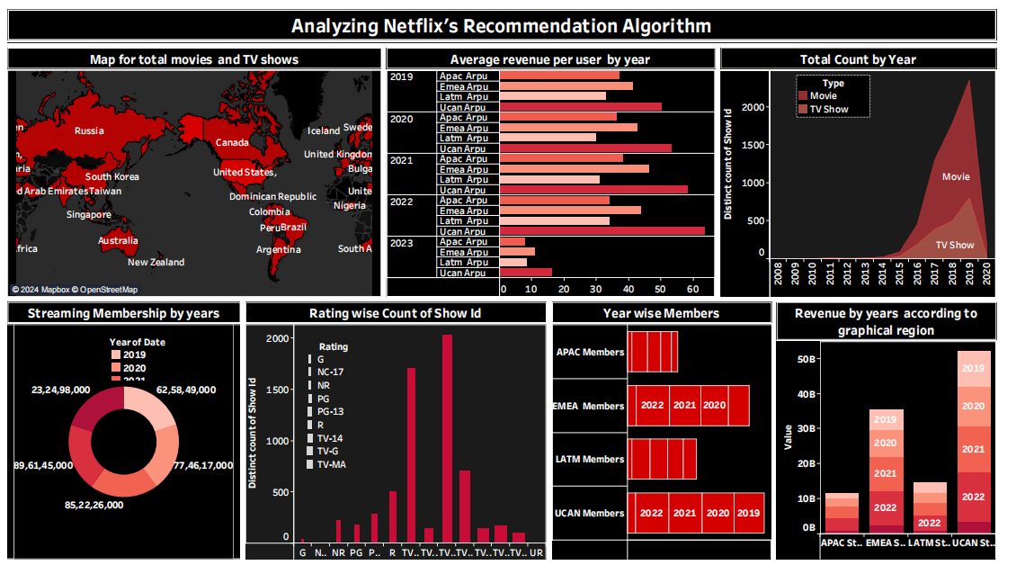**Dashboard :**

**The dashboard shows how Netflix uses data to make better recommendations**. It looks at things like what movies people watch, where they live, and how much they pay. This helps Netflix suggest movies and shows that people will enjoy. The dashboard helps Netflix improve its service and make more money.

**List of Charts from the Dashboard**

1. 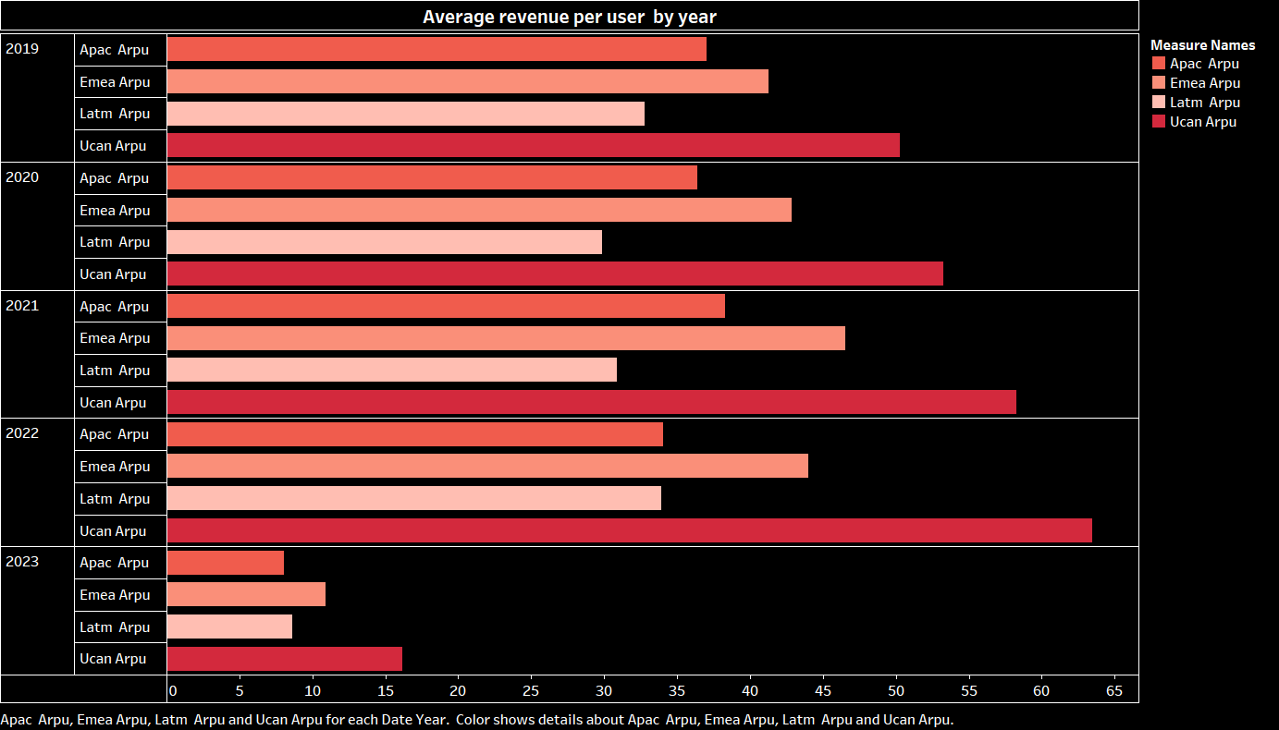**Average Revenue per User by Year:** A bar chart comparing the average revenue per user (ARPU) for different regions over time.
2. **Map for Total Movies and TV Shows:** A world map showing the distribution of Netflix content across different regions.

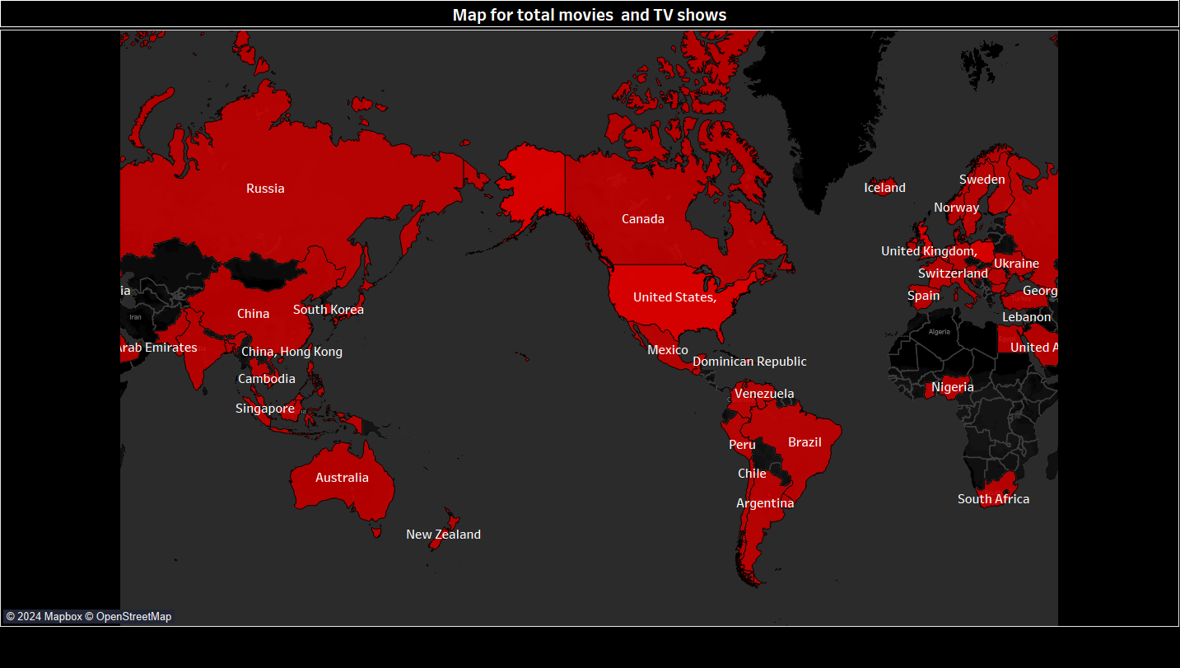

1. **Total Count by Year:** A line chart illustrating the total number of movies and TV shows on Netflix over the years.

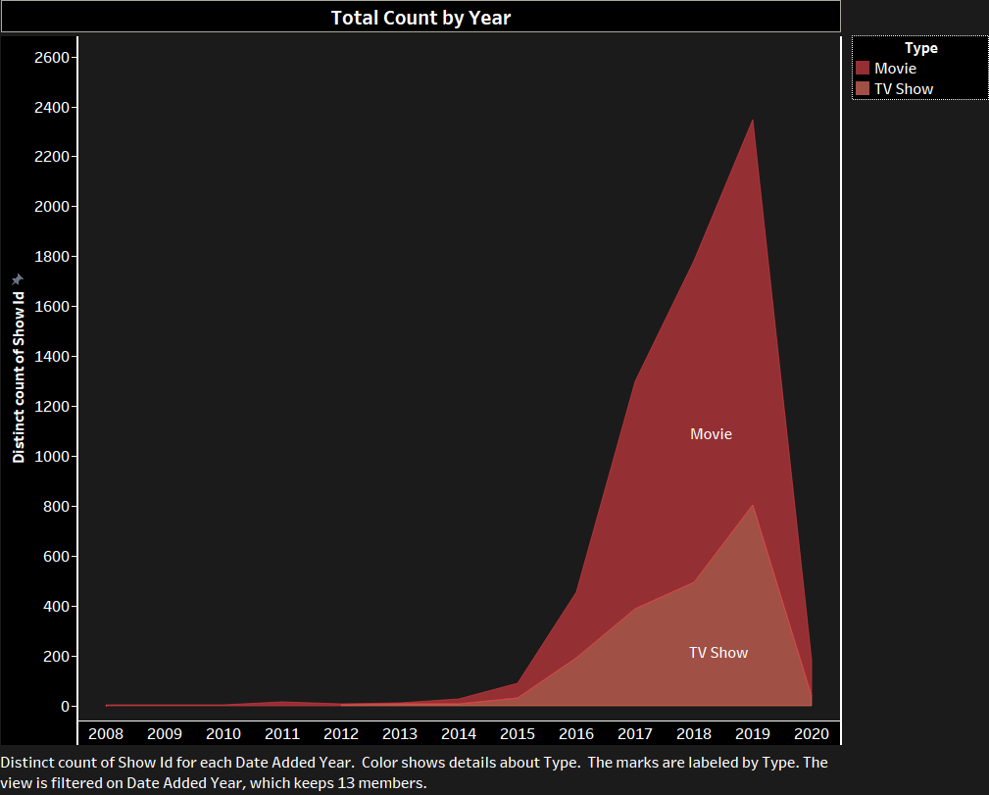

1. **Streaming Membership by Years:** A pie chart representing the distribution of streaming memberships across different years.

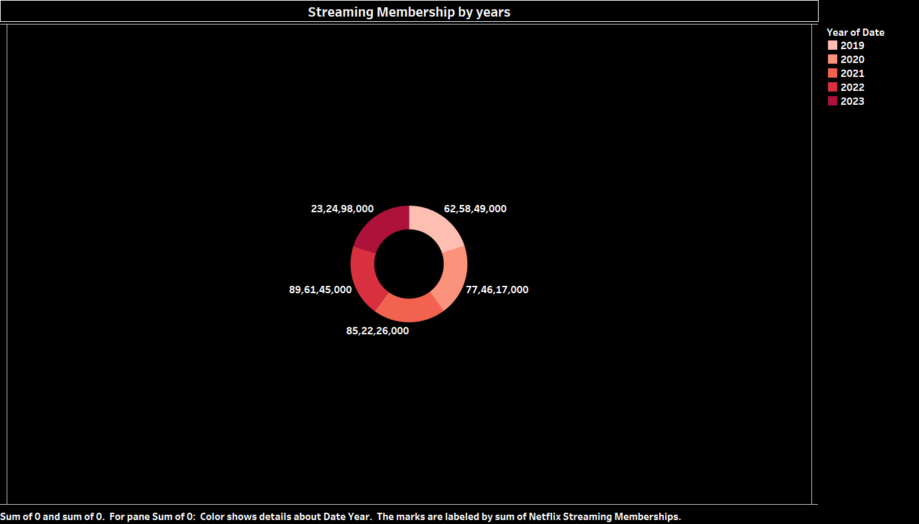

1. **Rating-wise Count of Show ID:** A bar chart showing the count of shows based on their ratings.

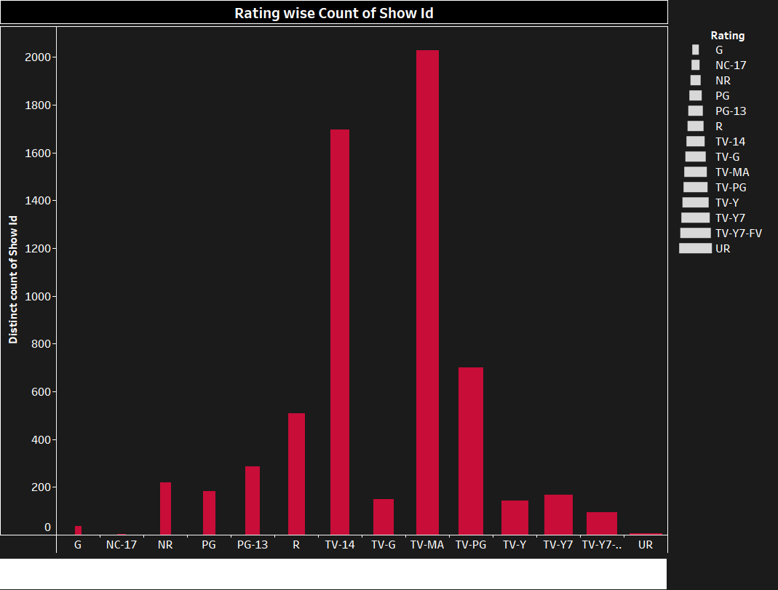

1. **Year-wise Members:** A bar chart comparing the number of members in different regions (APAC, EMEA, LATM, UCAN) over time.

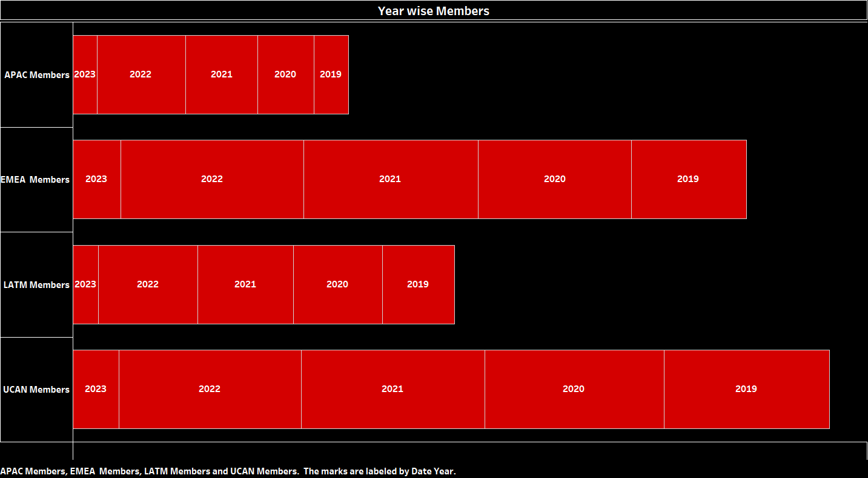

1. **Revenue by Years According to Graphical Region:** A stacked bar chart representing the revenue generated by each region over the years.

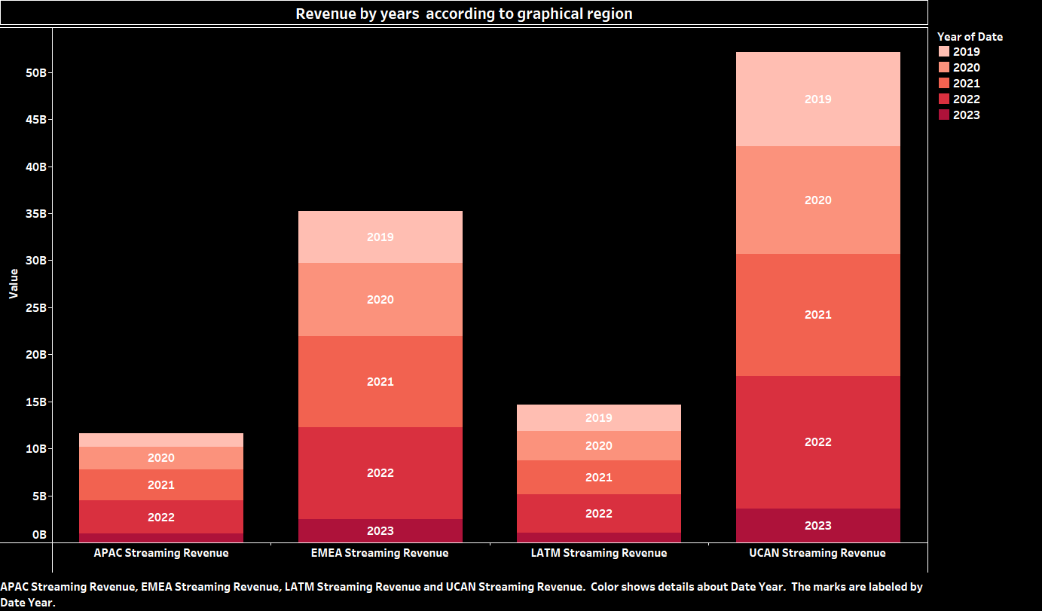

**Reference List**

**[1]. Tools:**

* **Tableau Software.** (2024). Tableau Desktop. Retrieved from <https://www.tableau.com/products/desktop/download> (Consider including this reference if you used Tableau to create your charts)

**[2]. Dataset Sources:**

* **Kaggle, M.** (2024). Netflix OTT Revenue and Subscribers. Retrieved from <https://www.kaggle.com/datasets/mauryansshivam/netflix-ott-revenue-and-subscribers>. (Modify author initials if different)
* **DataScienceRoadMapDSRM.** (2024). Netflix Titles.csv. Retrieved from

<https://github.com/DataScienceRoadMapDSRM/Tableau-Dashboards-info/blob/main/netflix_titles.csv>.